Age divide, Health divide, Wealth divide, Rural-urban divide

Premechanical : Petroglyphs, the first numbering system, The first calculator (Abacus)

Mechanical : Slide rule, Difference engine, Pascaline

Electromechanical : Telegraph, Morse code, Telephone. Radio

Electronic : Vacuum tubes and rotating magnetic drums (ENIAC & Mark 1), Transistors, magnetic tape and magnetic cores (FORTRAN & COBOL), integrated circuits and semiconductors, CPU, memory, logic and control circuits (Apple II), ICT, Autonomous vehicle

ICT is the technology required for information processing : Information Technology, Telecommunication Technology, Networking Technology

Input device :

Output Device :

Storage Device :

communications device :

Advantages of Using Computers : Speed, Reliability, Consistency, Storage, Communications

Green computing

Recycling , Using energy efficient hardware and energy saving features , Regulating manufacturing processes , Extending the life of computers , Immediately donating or properly disposing of replaced computers

Network : collection of computers and devices connected together, often wirelessly, via communications devices and transmission media

Internet : worldwide collection of networks that connects millions of businesses, government agencies, educational institutions, and individuals

social networking Web site = online social network

Photo sharing community , Video sharing community, Professional community(LinkedIn, XING, Viadeo, ResearchGate) , Volunteering community( Couchsurfing, Hospitality Club, BeWelcome )

Software, also called a program, tells the computer what tasks to perform and how to perform them

System Software • Operating system/Tools , Applications

Installing is the process of setting up software to work with the computer, printer, and other hardware

A software developer, sometimes called a developer or programmer

A personal computer can perform all of its input, processing, output, and storage activities by itself

Two popular architectures are the PC and the Apple – Desktop computer

Mobile Computer : Personal computer you can carry from place to place (notebook computers, laptop computers, netbooks, and Tablet PCs)

Mobile Device : Computing device small enough to hold in your hand (smart phones, PDAs, e-book reader, handheld computers (Ultra mobile PC), portable media players, and digital cameras)

game console is a mobile computing device (Xbox, Wii, PlayStation4)

• A server controls access to the hardware, software, and other resources on a network

– Provides a centralized storage area for programs, data, and information

• A mainframe is a large, expensive, powerful computer that can handle hundreds or thousands of connected users simultaneously

A supercomputer is the fastest, most powerful computer

– Fastest supercomputers are capable of processing more than one quadrillion instructions in a single second(weather forecasting, climate research, oil and gas exploration, molecular modeling physical simulations)

An embedded computer is a special-purpose computer that functions as a component in a larger product

Home User, Small/Home Office User, Mobile User, Power User, Enterprise User

To connect to the Internet you need 1. An access device (computer with modem) 2. A means of connection (phone line, cable hookup, or wireless) 3. An Internet access provider

A hot spot is a wireless network that provides Internet connections to mobile computers and devices

A cybercafé is a location that provides computers with Internet access, usually for a fee

An Internet service provider (ISP) is a business that provides individuals and organizations access to the Internet free or for a fee

Internet Backbone: High-speed, high-capacity data transmission lines, usually fiber optic.

Bandwidth: Expresses how much data can be sent through a communications channel in a given amount of time.

Baseband: Slow type of connection that allows only one signal to be transmitted at a time.

Broadband: High-speed connections

Protocols : electronically transmit data -TCP/IP (Transmission Control Protocol/Internet Protocol) is the Internet protocol • Developed in 1978 by ARPA

Packets : Fixed-length blocks of data for transmission, determined by TCP/IP , Data transmissions are broken up into packets and reassembled at destination (the IP—Internet Protocol— address)

Dynamic IP addresses change with every use; individual computer

Static IP addresses don’t change (established organizations –

A domain name is a text-based name that corresponds to the IP address

A DNS server translates the domain name into its associated IP address – generic Top-level domain (gTLD)

Basically, no one owns the Internet

Internet Corporation for Assigned Names and Numbers (ICANN) regulates domain names (such as .com, edu., .net) that overlie IP addresses; ICANN does not control content

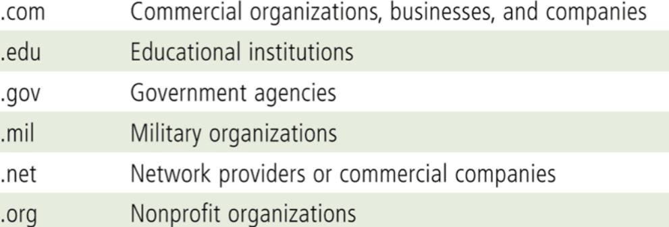

The World Wide Web, or Web, consists of a worldwide collection of electronic documents (Web pages)

A Web site is a collection of related Web pages and associated items

A Web server (website server) is a computer that delivers requested Web pages to your computer

Web 1.0 “read-only”, “look but don’t touch basis” Examples are Online dictionaries, Personal web pages, Britanica Online, Web pages of universities etc.

Web 2.0 refers to websites that provide a means for users to share personal information, allow users to modify website content, and provide applications through a browser

social networking sites, e.g., Facebook, LinkedIn, Mediasharing sites, e.g., YouTube, Flicker, Shutterfly and Social-network aggregator e.g., Mugshot, Readr

Web 3.0 (also called Semantic Web), : human interaction required to discover and integrate that information.

Two ideas might form the basis for Web 3.0— semantic markup and a personal browser

A Web browser, or browser, is an application that enables users with an Internet connection to access and view webpages on a computer or mobile device

Web Page is a document on the web that can include text, pictures, sound, and video

The first page on a website is the Home page

The Home page contains links to other pages on the website (and often other websites) – Surfing the Web

• History List – Allows you to easily return to a particular site

Bookmark – Allows you to store the URL from a site on your computer so you can find it again in another browser session – To save the URL for a site, click on “Favorites” in Internet Explorer, “Bookmarks” in Mozilla Firefox, or the star icon in the URL address bar in Chrome

A Web page has a unique address called a Uniform Resource Locator (URL) or Web address

A search engine is software that finds website ….

Databases of search engines are compiled using software programs called spiders (aka, crawler, bots, agents)

1. Individual Search Engines : e Ask, Bing, Google, and Yahoo!
2. Subject Directories : Created and maintained by human editors, not electronic spiders – Example sites are Beaucoup!, LookSmart, Open Directory Project, and Yahoo! Directory
3. Metasearch Engines : Metasearch Engines : Allows you to search several search engines simultaneously Examples are Yippy!, Dogpile, Mamma, MetaCrawler, and Webcrawler
4. Specialized Search Engines : Help locate specialized subject matter, such as info on movies, health, jobs – Examples are Career.com. WebMD, Expedia, U.S. Census Bureau

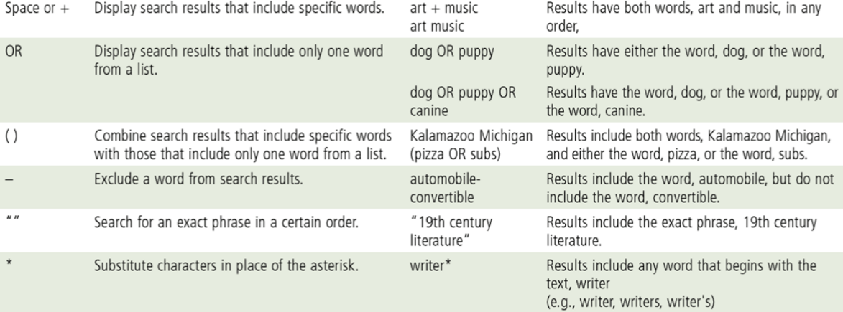

A graphic is a digital representation of nontext information

Graphic formats include BMP, GIF, JPEG, PNG, and TIFF

A thumbnail is a small version of a larger graphic

An infographic is a visual representation of data and information, designed

Animation is the appearance of motion created by displaying a series of still images in sequence

Animators : creation of animation

Computer animation, or CGI animation the process used for generating animated images.

Streaming is the process of transferring data in a continuous and even flow

Video consists of full-motion images that are played back at various speeds

Moving Pictures Experts Group (MPEG) MPEG-4 or MP4. The volume of Internet traffic is increasing mostly because of Internet videos and social networking.

Virtual reality (VR) is the use of computers to simulate a real or imagined environment that appears as a three-dimensional space

A plug-in is a program that extends the capability of a Web browser, Multimedia Applets

Web publishing is the development and maintenance of Web pages

– web development software

– an Internet connection

– web server

Posting updates on social networking websites like Facebook and Twitter is generally not considered web publishing.

E-mail is the transmission of messages and files via a computer network

Email Program : Enables you to send email by running email software on your computer that interacts with an email server at your Internet access provider

Web-Based Emai : You send and receive messages by interacting via a browser with a website

IMAP: Internet Message Access Protocol. POP3: Post Office Protocol version 3

Instant messaging (IM) is a real-time Internet communications service

VoIP (Voice over IP) enables users to speak to other users over the Internet – Also called Internet telephony

Push technology: Software that automatically downloads information to personal computers.

Webcasting: Sending users customized text, video, audio on regular basis. (Broadcast (an event) on the Internet.)

RSS newsreaders (RSS aggregators): Programs that scour the web, sometimes hourly, sometimes more frequently, and pull together in one place “feeds” from several websites. – RSS is based on XML,

Blogs (weblogs)/vlog are frequently updated sites on the web intended for public consumption

– Blog/vlog/microblog/blogsphere

Podcasting : nternet radio or similar Internet audio program delivered via RSS feed to a subscriber to be played back on computer or digital audio device.

Netiquette is the code of acceptable Internet behavior